Feature Log 5

This iteration includes two features that improve accessibility and compliment other features previously created. Two stable features were researched, created and made stable. Taken into consideration how the user thinks and also how the code is properly structured.

Feature 1 : Reprogramming Keys

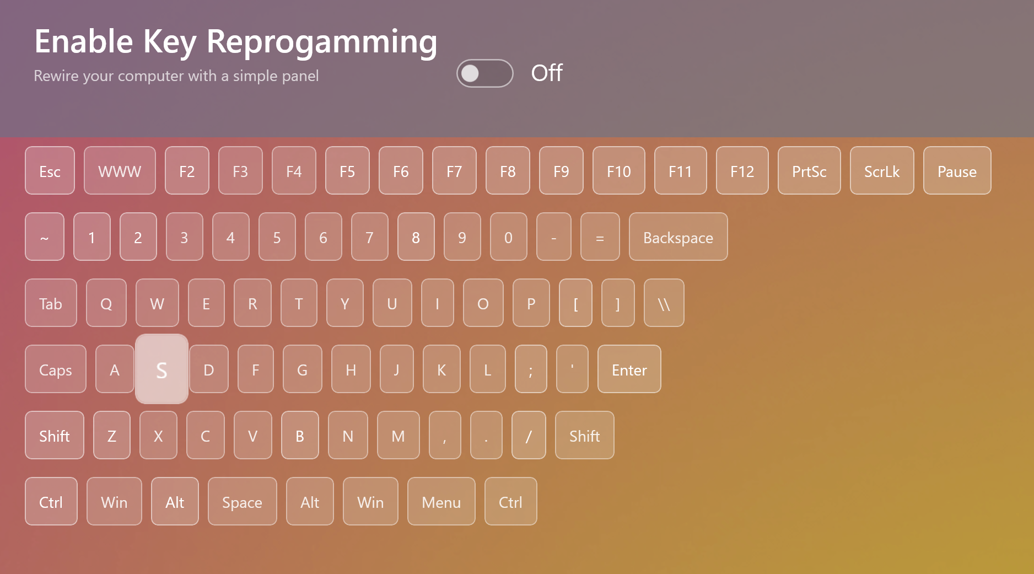

Use Cases / Relevancy
This accessibility feature is aimed towards people with broken keys. Complimenting the feature of iteration 3 that helps with broken touchpads. It also aimed towards developers or computer enthusiasts to customise certain actions that may be relevant to them by reprogramming keys for abstract use cases , eg., Left Alt Key positioned permanently at Right Meta Key
Broken keypad ; The user may have keys not functioning that impedes there work.
Ergonomics: User may find it easier if input was repositioned that cant be done normally.

Ui Design
Since there can be < 86 keys for the to choose to reprogram .This means theyre can be possible < 86 keys to keep track of .Each key is correctly shown the to the user mirroring its physical position . The UI virtual keyboard is responsive to both the mouse and the keyboard when chooses.

Time and Space Complexity
In terms of design and efficincy it has no relation to input size and time / space complexity . Duplications and registration of specific hotkeys are filtered and retrieved through a hashset which is constant complexity anyway . In certain edge cases of duplication or reserved keys in any combination that could happen out 86 x 86 combinations is still becomes constant time due to hashcodes creating specific identifiers .

Feature 2 : Tiling Manager
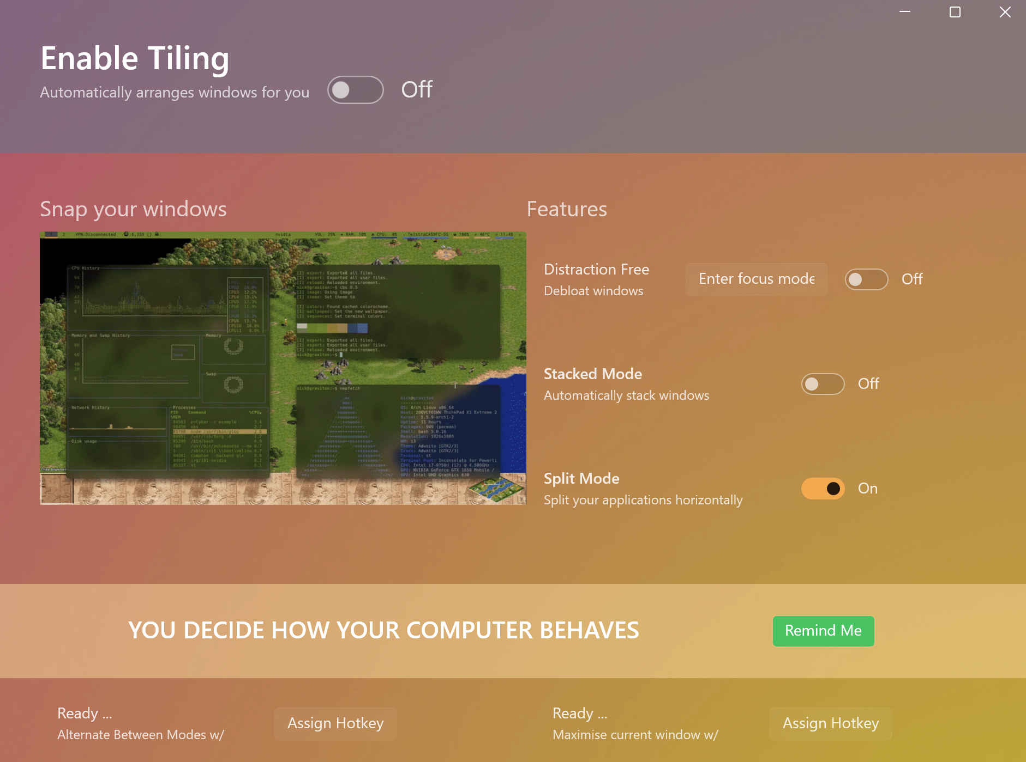

Intro
Since the project is aimed towards making the computer easier to use I can target different categories of users – this feature targets developers, project managers , and anyone who multitasks in a professional environment .

What is a tiling manager
They are way for people automatically organise open applications .What this means in application is that tasks that become increasingly complex for the user become increasing organised .It enforces clarity for the user when in any given task.

In application:
In literal terms this means that any open applications are enforced to be have an equal position on the monitor and to equally divide the open applications into the users line of sight . When the user chooses to focus on one they can input a programmed key to maximise the window instantly . This makes focusing and seeing a birds eye view of all open applications seamless and instant with one key stroke.

Use Cases :
This has knock on effects for the user in terms of productivity – anything using up memory is shown the user and not lost in sight – they are indirectly guided to release memory and resources used up by applications making your computer faster. This helps in terms of accessibility because the applications thinks for you while you are multitasking .

Integration of other features into the design .
To increase accessibility integrating dynamic hotkeys made it so that the user can transfer the all options in the ui to the keyboard to be changed on command instantly outside of the application using the keyboard hooks / combinations .
In theory using the application someone could traverse the computer using all enabled features and they would not hinder eachother but instead compliment eachother .

